5a)

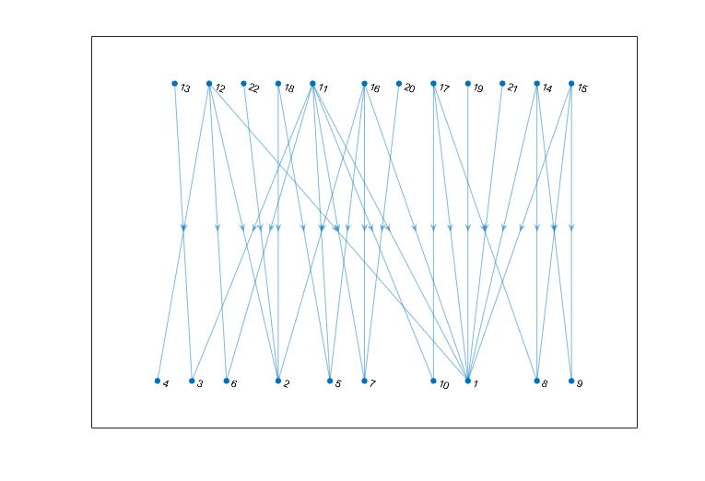

*Figure 1: Bipartite Graph for pollinators and plants*

b)

%% Part b

Nodes 1-10 are plants and 11-22 are pollinators

c)

A max of 10 edges can be made as the bipartite graph is not perfectly matched, i.e. there is an unmatched number of plants to pollinators. Additionally, the bipartite matching function matched such that there would be at least one pollinator assigned to each plant.

d)

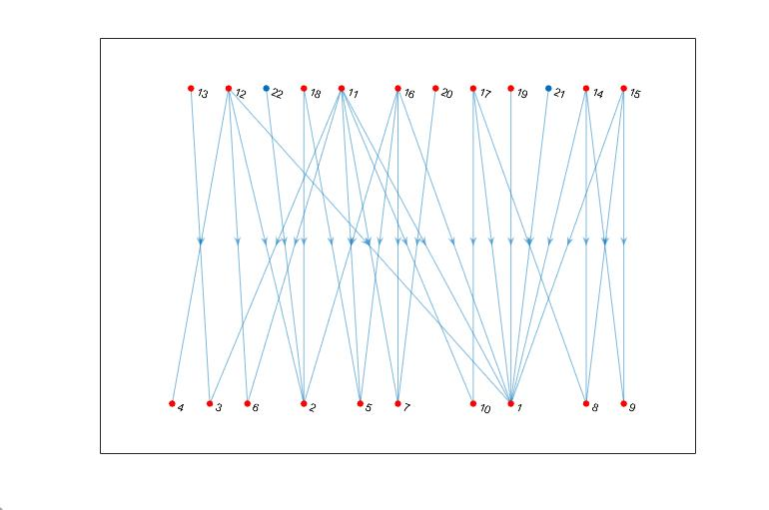

*Figure 2: Pollinators and plants including highlighting for matched nodes*

%% Q6

%% Part a

For an Erdos-Reyni model of random graphs, a giant component will begin to form when the mean degree of the vertices is 1 i.e. c = 1. This follows that p = c/(n-1)

for n = 1000, p = 1/999 = 0.001

for n = 10000, p = 1/9999 = 0.0001

%% Part b

For the value where p < 0.001, there were much closer to 1000 groups, however when p > 0.001, the number of groups became much smaller, indicating groups were forming and there were fewer individual nodes. This indicates the appearance of a giant component, or a group which consists of a finite fraction of the nodes in a graph.

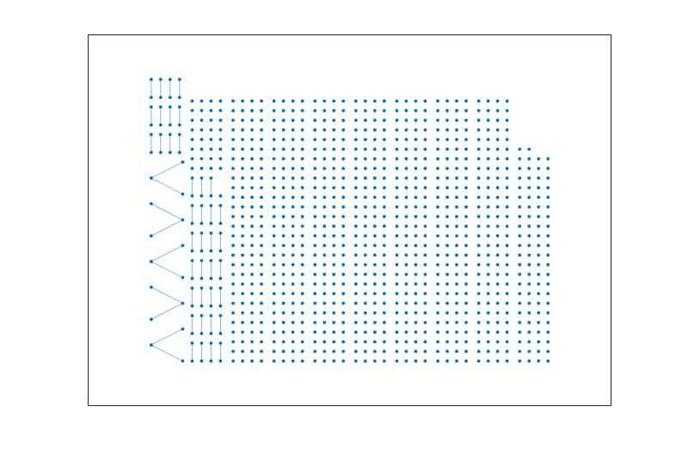

*Figure 3: n = 1000, p = 0.0001*

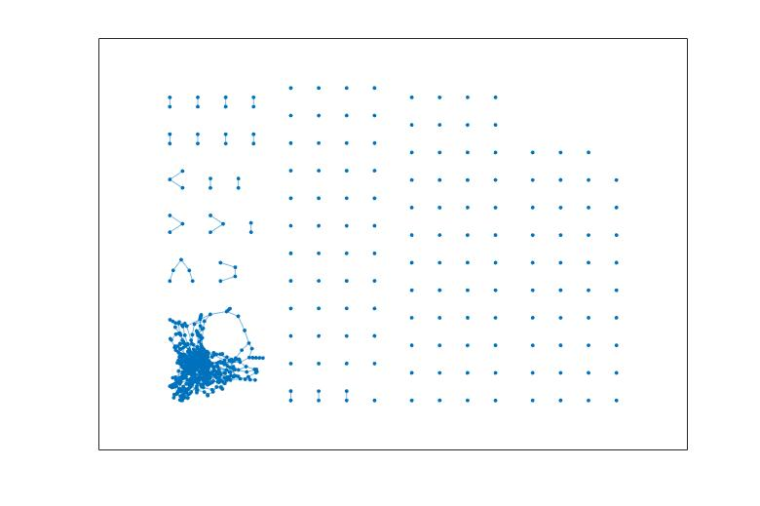

*Figure 4: n = 1000, p = 0.002*

%% Part c

For an Erdos-Reyni model of random graphs, when c > ln(n), the graph will almost surely be completely connected.

For n = 1000, p = ln(1000)/1000 = 0.0069

For n - 10000, p = ln(10000)/10000 = 0.00092

%% Part d

For the value where p < 0.0069, there was more than 1 group, indicating that the graph was not fully connected, however when p > 0.0069, the number of groups became 1, indicating the presence of only one group of nodes in the network. This meant the network had become fully connected when p > 0.0069 for a network of 1000 nodes.

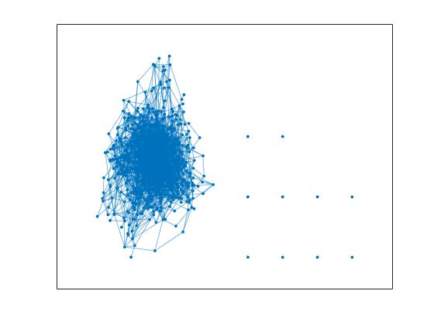

*Figure 5: n = 1000, p = 0.005*

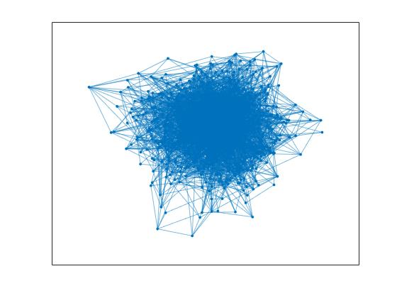

*Figure 6: n = 1000, p = 0.008*